April 2018

ENTERPRISE CAMPUS NETWORKING  
Network Automation and Programmability Abstraction Layer  
Setup Guide



Jesus Mendez  
mendezj@staticoverride.us

Contents

**Interpreter** 3

**Compiler** 3

**Libraries** 3

**Netmiko** 4

**N.A.P.A.L.M** 5

**Ruckus FastIron N.A.P.A.L.M** 5

**Importing** 5

**Appendix** 6

Python MACOSX 6

PIP Install Netmiko 6

PIP Install NAPALM 6

PIP Install NAPALM-RUCKUS-FASTIRON 6

**Installation requirements** 6

Hardware requirements 6

**Reference** 6

# **Interpreter**

The first step in a fresh environment is to install the Python interpreter on your local device. The responsibility of the interpreter is to understand the Python programs by reading and carrying out its instructions. If your environment is MAC OSX distribution 10.3 or greater your computer may include a version of Python. Please see Appendix item *Python MAC OSX* for further instructions.

1. Go to <https://www.python.org/> and install the latest Python 3.X.X interpreter corresponding to your computers environment.

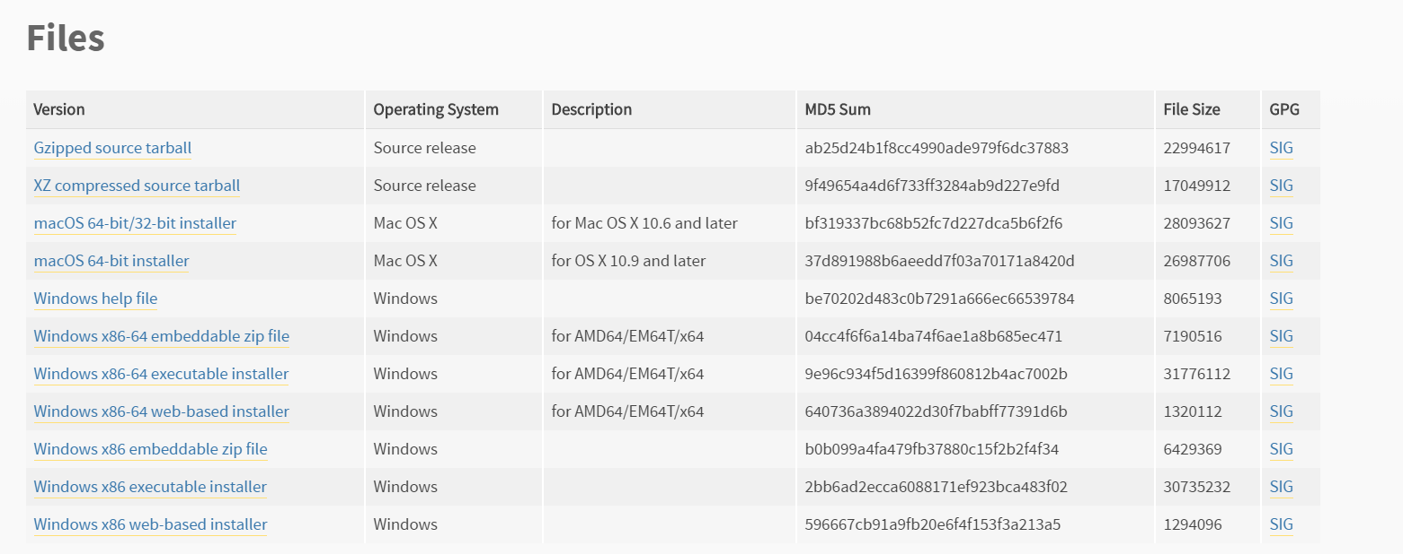

# **Compiler**

The next step is to install your favorite Compiler. While any Python compiler works just fine, for simplicity sake I recommend Pycharm Community. The main responsibility for a compiler is to take your computer program written in a high level language “Python” and convert it to your computers native language.  
  
1. Install Pycharm Community

<https://www.jetbrains.com/pycharm/download/#section=windows> [Windows]

<https://www.jetbrains.com/pycharm/download/#section=mac> [macOS]

<https://www.jetbrains.com/pycharm/download/#section=linux> [Linux]

# **Libraries**

While Python’s standard Library is extensive, it collection continues to grow as individual programs, modules, and plug-ins are created. The following libraries are required for Ruckus FastIron Napalm.

## **Netmiko**

Netmiko is a multi-vender library to simplify Paramiko SSH connections to network devices. To run Napalm Ruckus FastIron, Netmiko v 2.0.2 or higher is required. As this is the first version that supports FastIron.

1. Run the Python compiler and proceed to settings, then locate Project Interpreter sub-category.   
   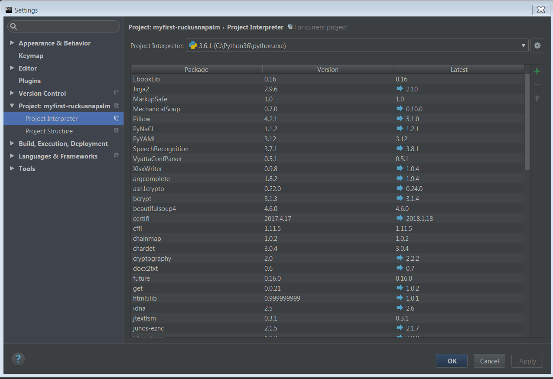
2. Click on the **green** **+** and search “netmiko” and install package.   
   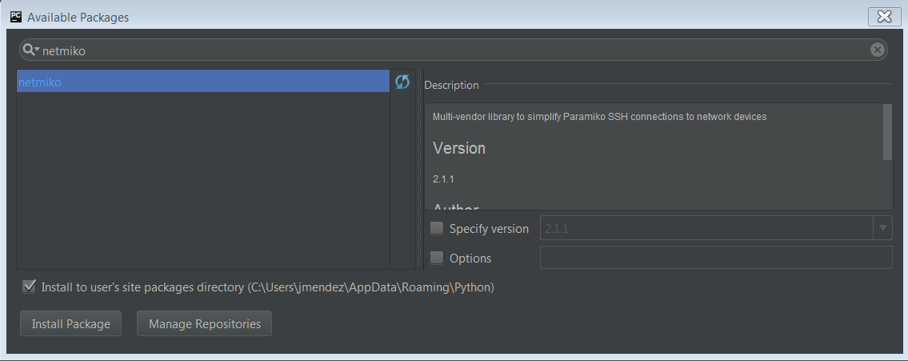

## **N.A.P.A.L.M**

NAPALM is a python library that implements a set of functions to interact with different router vendor devices using a unified API. Ruckus FastIron is currently a plug-in and uses Napalm’s base.  
  
1. Repeat the same steps as in the previous Netmiko section with the exception of searching for “napalm” and install the package.  
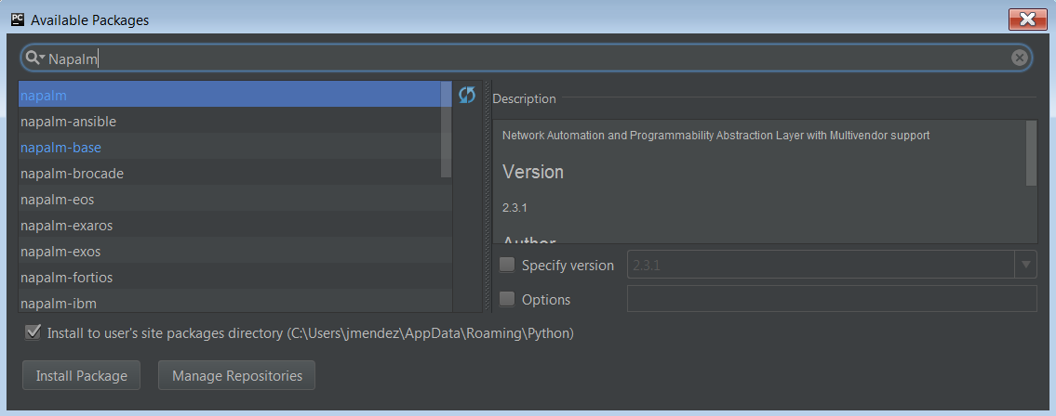

## **Ruckus FastIron N.A.P.A.L.M**

Now for the moment we have been waiting for, installing Napalm Ruckus FastIron. At the time of writing this document Ruckus FastIron is a standalone plug-in. Work is being done so it is published and installed similarly as how the previous two libraries were installed. However, today we have two work arounds on how to use the library will be explained in the next section, but first let’s download the file.  
  
1. Download the latest version: <https://github.com/Static0verride/napalm-ruckus-fastiron>

# **Importing**

Now the last step is to import the previously downloaded file so your program may use it. We have one of two options on how to import.  
**1A**. Point to the path that contains the ruckus_fastiron.py that we downloaded in an early step.

# some_file.py

import sys

sys.path.insert(0, '/path/to/application/app/folder')

import ruckus_fastiron.py

**1B**. Drag ruckus_fastiron.py into your project folder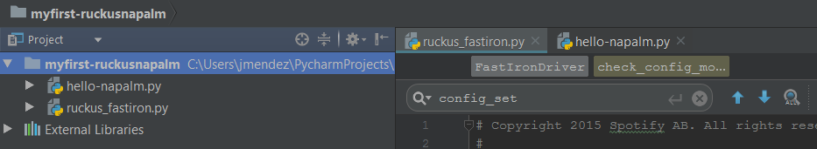

# **Appendix**

## Python MACOSX

Coming soon ☺

## PIP Install Netmiko

Coming soon ☺

## PIP Install NAPALM

Coming soon ☺

## PIP Install NAPALM-RUCKUS-FASTIRON

Coming soon ☺

# **Installation requirements**

## Hardware requirements

* 4 GB RAM minimum, 8 GB RAM recommended [PyCharm]
* 1.5 GB hard disk space + at least 1 GB for caches
* 1024x768 minimum screen resolution [PyCharm + Netmiko]

# **Reference**

<https://www.python.org/downloads/release/python-365/>

<https://www.jetbrains.com/pycharm/download/#section=windows> [Windows]

<https://www.jetbrains.com/pycharm/download/#section=mac> [macOS]

<https://www.jetbrains.com/pycharm/download/#section=linux> [Linux]

<https://pynet.twb-tech.com/blog/automation/netmiko.html>

<http://netmiko.readthedocs.io/en/stable/index.html>

<https://github.com/Static0verride/napalm-ruckus-fastiron>